How to … organise a Group Event

Thank you for your interest in organising a Group Event. This ‘How to …’ guide should provide everything you need to organise a Group Event including; how to obtain consent from DSAR, how to advertise on the website, etc.

Before a Group Event can take place, it will need to be approved by the DSAR Events Committee.
This can be achieved by completing the Events Notification form at the end of this document and returning in to the Events Coordinator you post it or email events@dsar.co.uk once approved your event will be listed on the Events Calendar both on the Web Site and the Forum.

To organise an event, you will also need to complete the following forms:

- Event Information Sheet
- Event Register

Notes on the Event Notification form
You must be a group member to organise a group event, if a third party organisation is being used for the event, for example track day instructors, they will need to contact the committee with details of their insurance and information about how they are going to run the event, but ultimately you will be responsible for the organisation of the event. You must include contact details, which will need to include at least a phone number. By agreeing to organise the event you give permission for these contact details to be placed on event advertisements on the web site or other media. The committee has the right to refuse an event for any reason. This decision is final.

Notes on the Event Information Sheet
The Event Information Sheet is provided to each of the attendees, on the day of the event and upon signing the Events Register. This sheet is designed to give the attendees information that will be necessary or useful about the event. We have attached a sample to give you an idea about how to complete the sheet, you do not need to follow this example to the letter but it will give you an idea about how to complete the form. You need to submit this completed form to the events coordinator 2 weeks before the event date. A sample sheet is included to give some guidance, also a blank one for you to use.

The Event Information Sheet must contain the following information:
- General details/description of the event (including a map, ir required)
- The standard DSAR disclaimer, always located at the bottom of the Sheet
- Event Rules or Ride Protocol. Any Emergency Procedures (Fire Exits etc.)
- An explanation of the Drop-off (or other) system being used to navigate
- Contact numbers of the event organiser
- Any specific key locations including postcodes (locations of planned breaks/stops)
- Any Separation Procedures if the participants become detached from the ride.

Notes on the Event Register
The template for the Event Register should be modified to include the title of the event, date and the ride leader and sweepers as appropriate. The purpose of this document is two fold, to allow the organisers a register of attendees for head count as well as other reasons. It is also an important requirement that anyone attending group events is aware of our disclaimer, all attendees MUST sign, including Pillions or guests if appropriate. After the event the registers must be returned in their original form to the events coordinator

On the day
Due to the nature of ride-outs and using the drop-off system, and also from previous experience, ride-outs will be limited to a maximum of 20 riders in any one travelling group. If the turn out it is larger than 20 the event must be split into two or more groups, each with it’s own leader and sweeper. It is important therefore to request attendees confirm with the event organiser prior to the event to confirm numbers. The pre ride brief may be delivered to all of the sub groups simultaneously, but the ride leaders are responsible for the navigation and pace control of their subsequent sub group.

Pre Ride Brief;
The following points must be discussed at the start of the ride, and please check if the members understand what has been discussed and encourage any questions about the understanding of the brief.

- Ride legally at all times and do not exceed the speed limits.
- DO NOT TRY to keep up, there is no need because of the drop off system and it is dangerous
- Follow at a safe distance and do not intimidate the rider in front of you.
- Ensure that the junction markers stop in a safe place and do not confuse other road users.
- Make your own decisions do not get drawn into manoeuvres by the rider in front.
- You are responsible for your own actions.
- Do not overtake other riders in the group unless the rider in front invites you through.
- What to do if you become separated or break down.

During the ride;
It goes without saying that if you are leading a ride, you will have little direct control over the following riders actions, but as you are leading a group event you carry a responsibility to deliver the event in the safest possible way. You should carefully consider the route and ensure that the pace is appropriate for the least experienced rider, use your mirrors to scan the group and spot any large gaps appearing, adjust the pace appropriately or have a quick stop to regroup. Try to point the markers to the safest point to mark the junction.

After the ride;
It is the organiser’s responsibility to ensure a post-ride write up is provided to the Events Coordinator as feedback within one week of the event. The Events Coordinator then will upload this to the website, which actively promotes the Group and allows other events to be openly discussed. And don’t forget to send in the completed Events Register!

Events Timeline
Whilst events can be planned and provided quicker than that shown, the following process should still be used. The timeline below gives the usual format for organising a successful event:

Timeline | Example | Action
Three weeks prior | 6th March | Create & plan your route, including the start, finish and break venues. This can be done through Google Maps, AA Route Planner, etc or alternatively you can ride the route if necessary, check venues and timings.
Three weeks prior | 6th March | Organise a Ride Leader and Ride Sweeper (they must be Passholders).
Three weeks prior | 6th March | Place all the information into the ‘How to ..’ template – using the Events Register, the Events Document and the Event Notification forms. Send these to the Event Coordinator for approval.
Two weeks prior | 13th March | The Event Coordinator responds within one week, and subject to approval, uploads your event onto the Events Calendar.
Day before | 26th March | Check the DSAR website, and Events Calendar to see how many riders have registered for the event.
Last Sunday of the month | 27th March | Host the Group Ride. The Ride Leader & Sweeper provides the pre-ride brief and explains the ‘drop-off’ or other system being used, etc
One week after | 3rd April | Organise the post-ride write up, and forward to the Events Coordinator

And finally ...
We hope that you have found this ‘How to …’ useful and informative. However, if you have any feedback or suggested improvements - please let us know by emailing: events@dsar.co.uk or colin@dsar.co.uk

Event Register

Event: Date:

Please complete your details below by attending this event you automatically agree to the disclaimer at the bottom of the page, a copy of this is available on request.

Pillions please put a P after the Bike Registration

Name | Mobile Number | Bike Registration | Signature
Ride Leader: Ride Sweeper:
Group Ride – Insert Title Insert date

Welcome,

“Today’s ride is a “Meet the Group” event/ride, and it is open to all riders of all skill levels. The idea is that new and potential members can meet the committee and other group members and take a look at the RoSPA style of riding but most importantly have a good, safe and enjoyable ride.” – Generic text to be modified

Below you will find details of the lunch stop and the contact numbers of the ride leader and sweeper. You will be riding with members of very different skill levels and as such we need to follow a few simple points for everyone’s enjoyment and safety, please stick to the ride protocol for the safety of the rider next to you. There is absolutely no pressure for you to keep up and you must ride at your own pace.

Ride Protocol
- You are responsible for your own machine and your own actions and decisions
- Ride at a pace that is safe for you, within your limitations and the law, DO NOT try to keep up with other riders
- There will be no overtaking other riders in the group, unless you are invited to by the rider in front
- You agree to indemnify D S A R, its members or the ride organisers of any claim or blame in relation to any incident or loss that may occur on the event. You agree to sign the event register.
- You agree to follow the instructions of the ride organisers at all times.

We will follow the “Drop off system” to navigate the route it is a simple method of marking the route and it means that even if you lose sight of the rider in front, you simply maintain a straight ahead course until you see a member of the group marking a junction, remember who is in front of you.

Drop off system is as follows, the Ride Leader is always at the front and is never overtaken, other riders follow in line and when the ride leader is going to deviate from a straight ahead course he will indicate to the following rider to mark the junction to indicate the change in direction, the rider following the leader must find somewhere safe to stop and mark the junction, be careful not to confuse other road users. Allow all the riders to pass you then rejoin the ride in front of the sweeper. This means all riders will rotate from the front to the back throughout the ride.

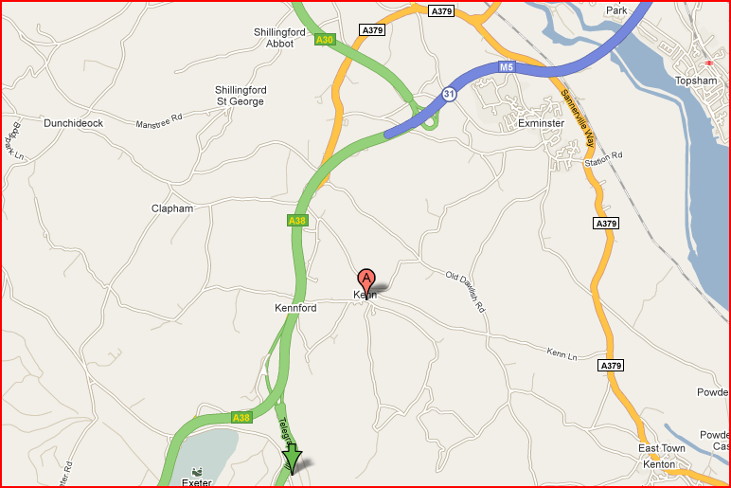Ride Leader Insert Name Insert Mobile
Ride Sweeper Insert Name Insert Mobile

If you get lost, we have estimated our
arrival for lunch at 12:45pm:

The Haldon Grill

EX6 7XW
(01392) 833700

Follow M5 south, join the A38, Then take
left fork onto A380 for Torquay/Paignton
At the top of Telegraph Hill The Haldon Grill
is on the left on the brow of the hill.

Event/Ride Notification

Event: Date:

Name of Organiser | Mobile number | Email address
Meeting Venue | Break Venue (if applicable) | Break Venue (if applicable) | Finish Venue
Description of Event or Route
Start time | Approx. finish time | Name of Ride Leader | Name of Ride Sweeper
Any further information, including emergency/foul weather plans
Don’t forget to include who will be writing the post-ride write-up.

